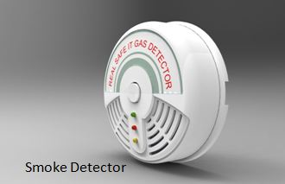

Product design for Smoke Detector

Product design of a smoke detector primarily involves a disk-shaped plastic enclosure engineered to securely house internal electronic components, facilitate air/smoke entry into a sensing chamber, and meet safety standards.

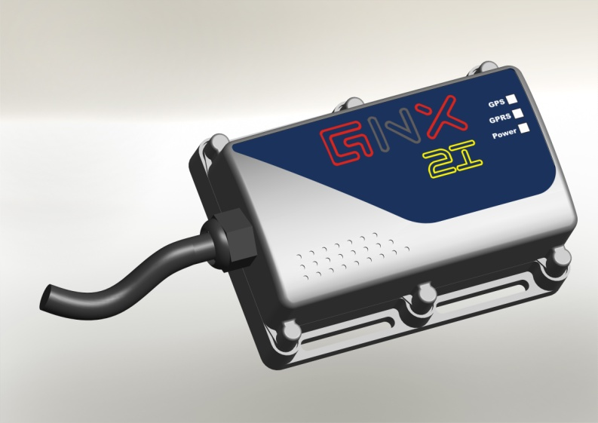

Automotive product design for Vehicle tracking system

- Aesthetical improved Compact Design of VTS.
- Engineering Design & Detailing of VTS.
- Engineering design with IP 65 Protection.

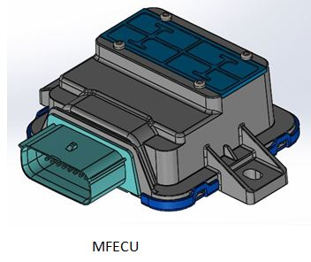

Engineering design for MFECU

1) Compact Engineering Design for MFECU. Plastic Enclosure Housing & Top cover – Plastic ABS material for MFECU

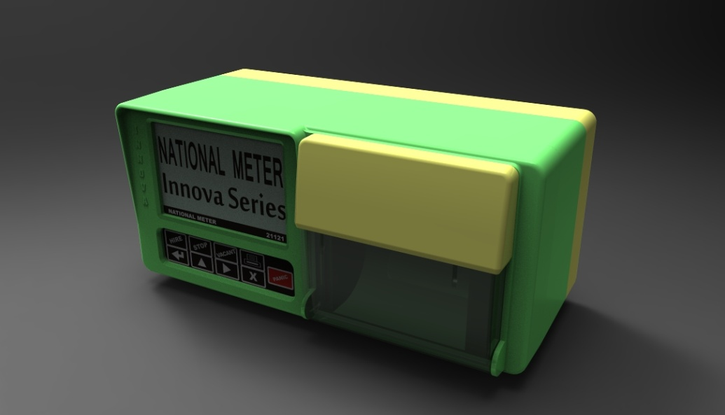
Enclosure Design for Taximeter

- Aesthetically improved Compact Design of Plastic Enclosure Housing – Plastic ABS +PC with IP65 protection for Taximeter.
- Engineering Design for Printer Mounting.
- Engineering Design of Cover in PC for Paper Roll.
- LED Illuminated indication on the back side of Meter for ‘FOR HIRE’.
- Engineering Design for Meter Mounting on Taxi/Rickshaw.

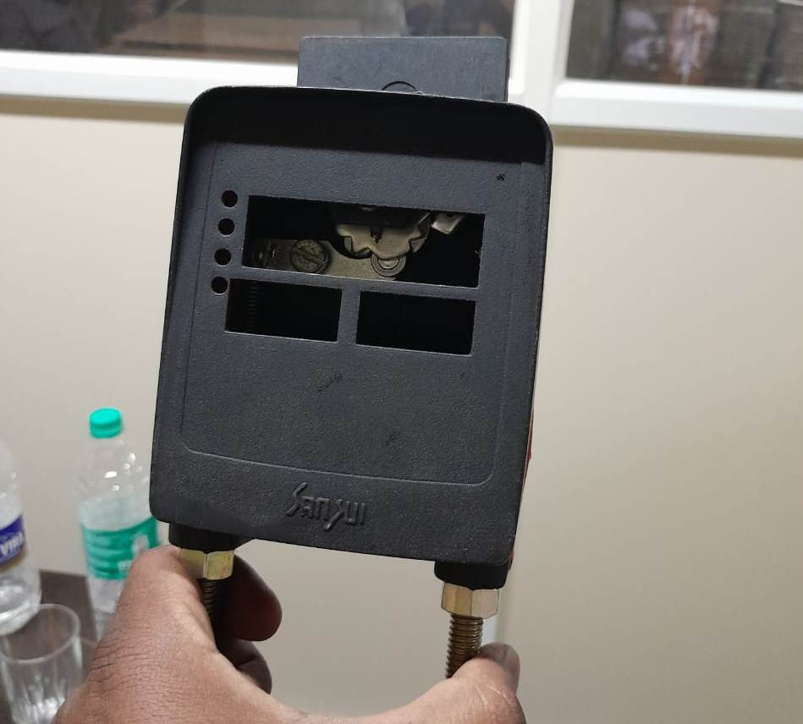

Prototype development for Jumbo meter flag compact

3D printed prototype development for breakthrough ideas

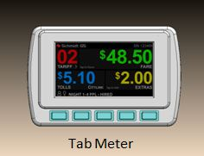

Electromechanical Product Design for Tabmeter

- Aesthetically improved Compact Design of Plastic Enclosure. Housing – Plastic ABS +PC with IP65 protection for Tabmeter.
- Engineering Design for display Mounting.
- Engineering Design for Meter Mounting on Taxi/Rickshaw.

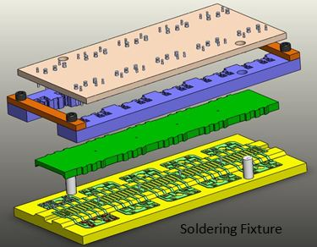

CAD Modeling and Mechanical design for Soldering fixture

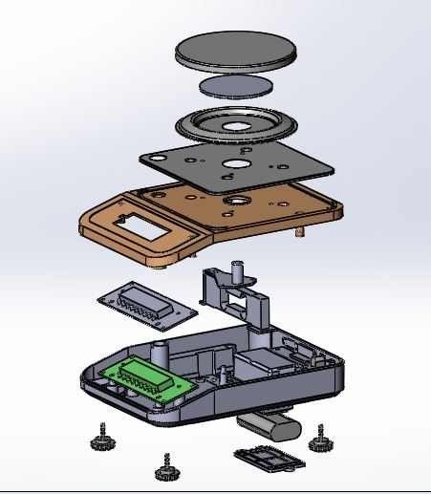

Plastic product design for JW weighing scale Precision 600g
- Aesthetically improved Compact Design of Plastic Enclosure. Housing – Plastic ABS with IP54 protection for weighing scale.
- Engineering Design for electronics and weighing scale Mounting.

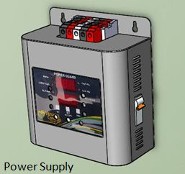
Sheet metal design for Power supply

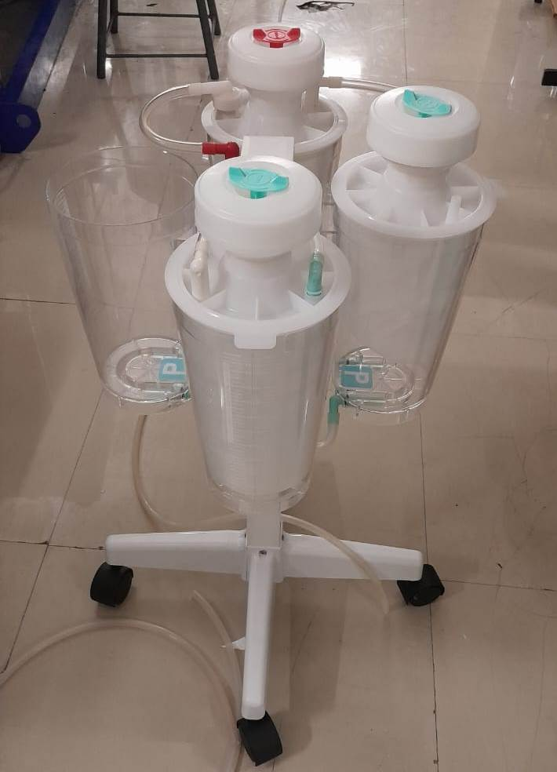

Reverse engineering for Suction unit (Medical product)

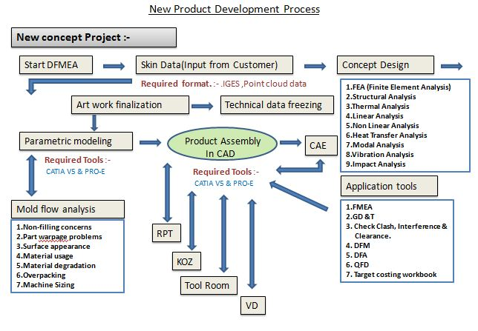

New Product Development process

